**Instruction Manual for Asha Department Store**

**Required specification:**

A file extractor program like WinRAR, a Microsoft Access database, and Visual Studio are necessities. For C# development, Visual Studio should be properly configured.

**Attached documents:**

A single zip file including both the access database and the application folder. To extract the zip file to the folder of your choosing, use the file extractor of your choice. Use the Microsoft database to view the Access database.

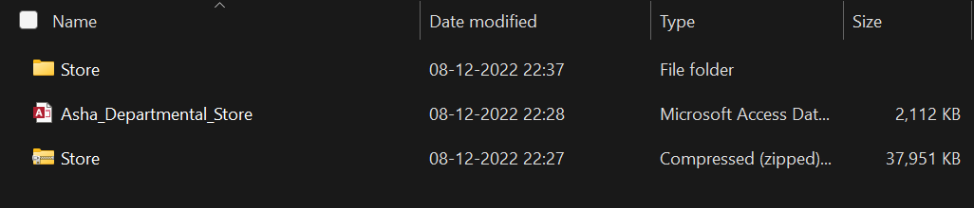

**Running the Visual Studio Application:**

To run the application, open visual studio and then open the path to the application by clicking on open project solution. Opening as a solution helps you to view the interface and run the application.

"C:\Users\hasri\Downloads\Software\Store\Store\Store\Store.sln"

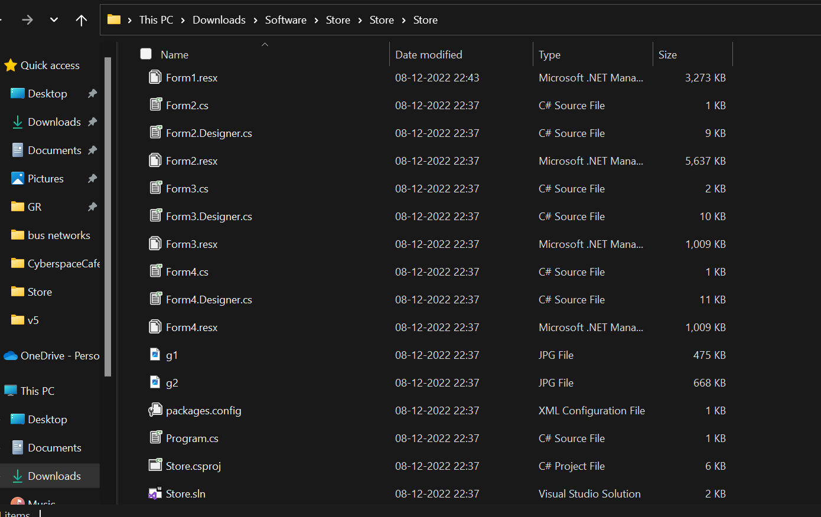

**Login Page:**

The moment you execute the sln file after opening it. The page where you enter your login information will be directed to you. The login credentials for the Admin is as follows

Email ID: [hasritha@gmail.com](mailto:hasritha@gmail.com) and password: hasritha.

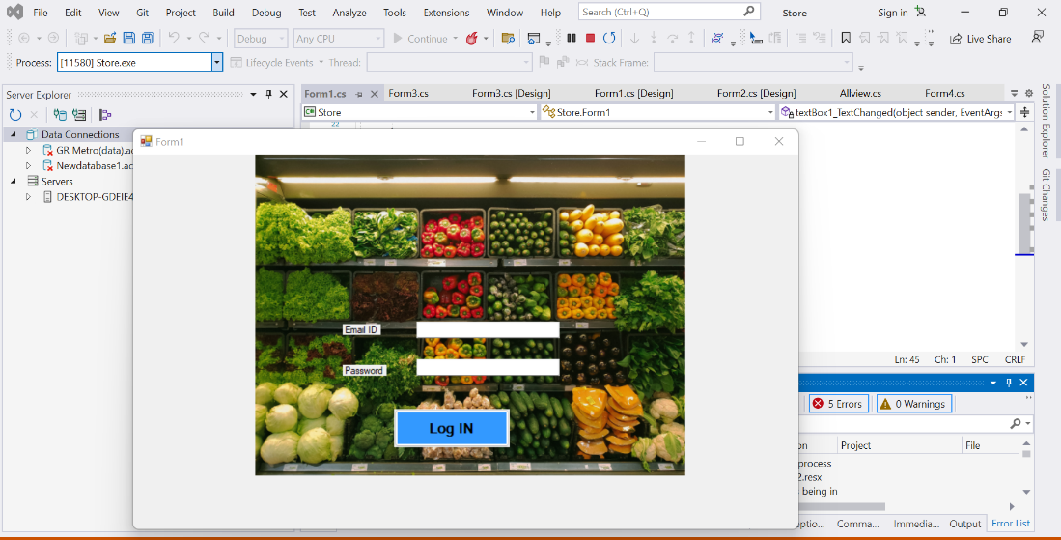

Once logged in, you must choose the box that says "agree to access the database."

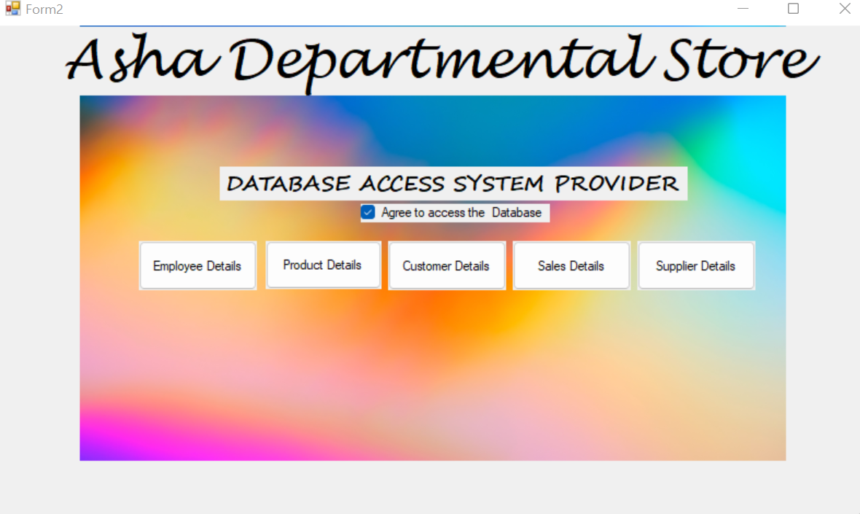

The employee details page, product details page, and sales details page are the three main interfaces I've introduced once you log in.

